COMPONENT DRIVEN DEVELOPMENT:

Breakdown overall application into small components, build them separately and then integrate them.

CDD means desigining software applications by building loosely coupled independent components.



























   




TOOLS FOR CDD:

BIT





























STORYBOOK:



REACT STYLEGUIDIST:











STORYBOOK:

It provides Much easier view of your component in a separate different state.

STARTING:

Create react app. Put this code at the end in package.json file

|  |
| --- |
| , |
|  | "devDependencies": { |
|  | "@storybook/addon-actions": "^5.3.19", |
|  | "@storybook/addon-knobs": "^5.3.19", |
|  | "@storybook/addon-links": "^5.3.19", |
|  | "@storybook/addons": "^5.3.19", |
|  | "@storybook/preset-create-react-app": "^3.1.4", |
|  | "@storybook/react": "^5.3.19" |
|  | } |

Then create folder

.storybook and create main.js file in it

After that create components as usual. Like create components folder, counter.js file in it and call it in App.js. Now to visualize this component, we need storybook. So add these two commands under scripts in package.json file

    "storybook": "start-storybook -p 9009 -s public",

    "build-storybook": "build-storybook -s public"

Now to run storybook, write yarn storybook in separate cmd

For stories, we use *.stories.js extension

In stories.js, we provide normal component name

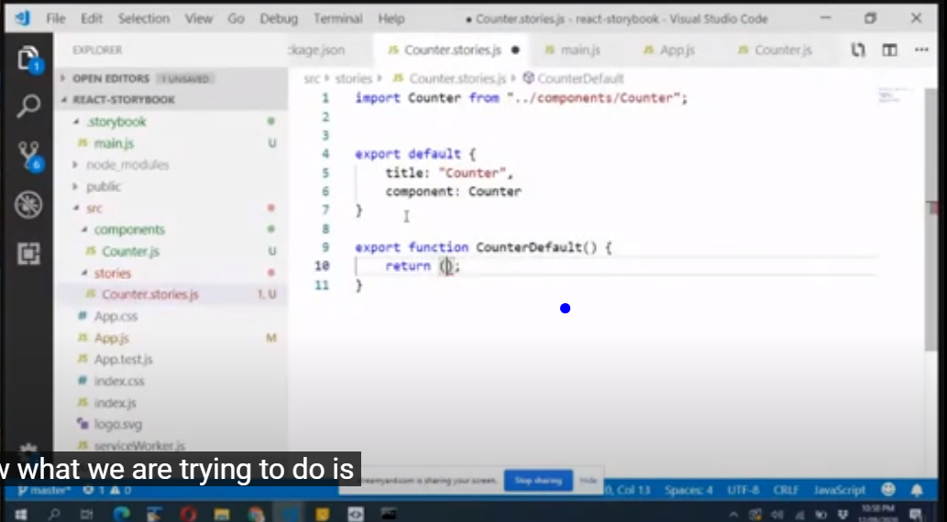

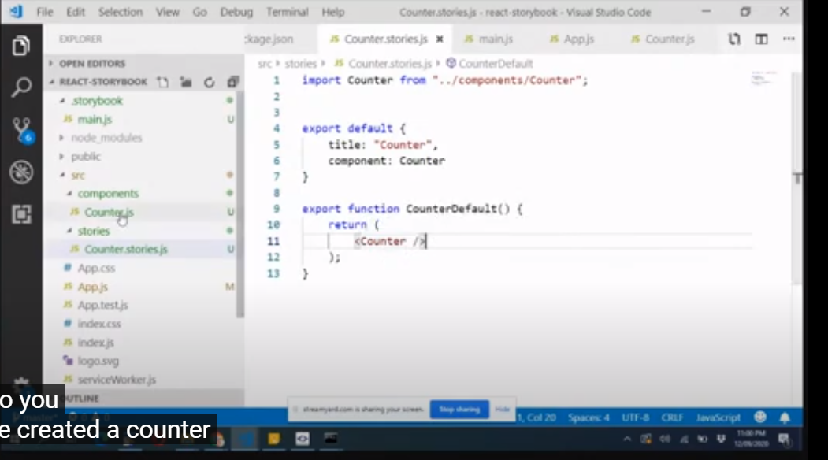

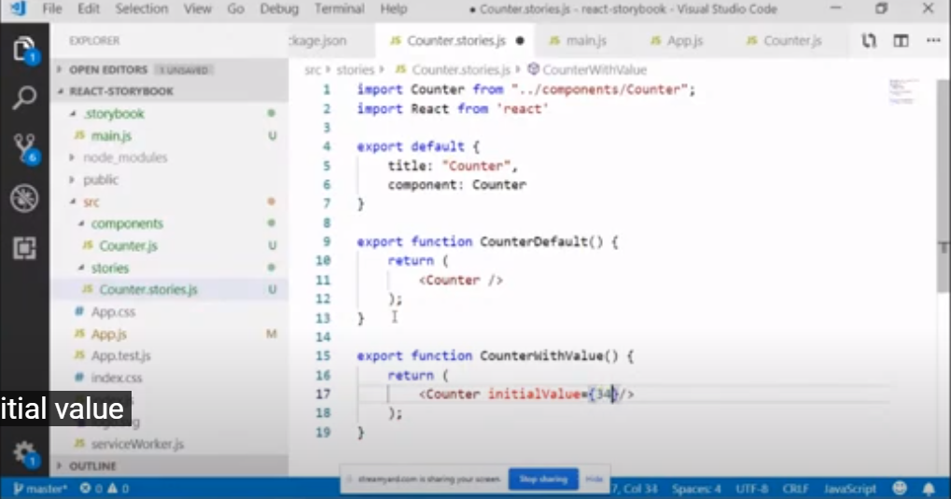

Adding background color to counter.js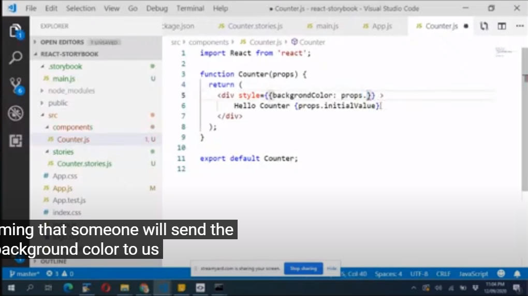

One thing to notice here that we are not providing any hardcoded values. The reason as they are components, so they can be utilized with different values. So we are generalizing them. Now Using it In stories

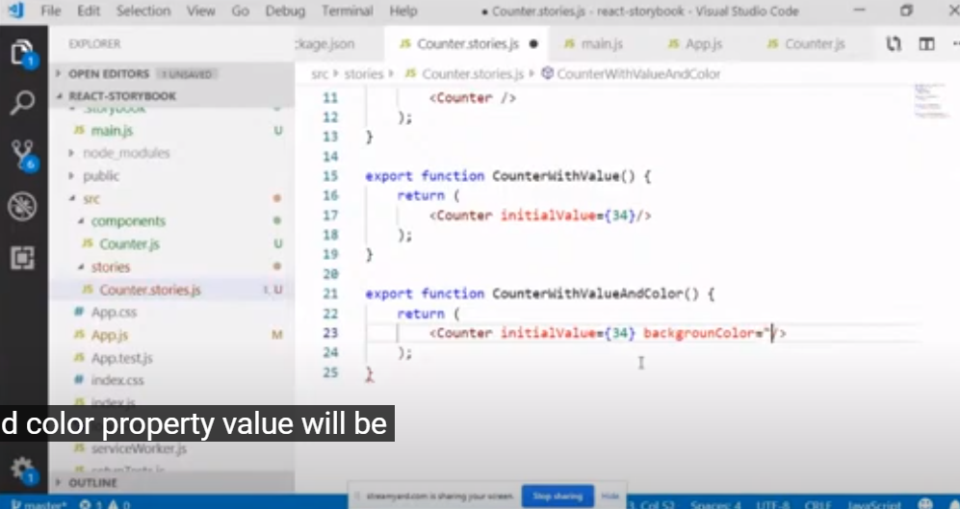

Now create button component

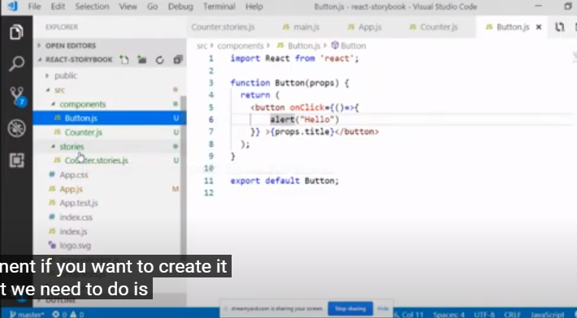

Calling it in counter.js

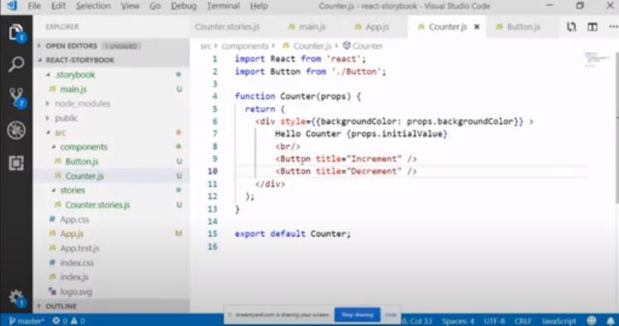As now we have created button components, now to use them, we need to create separated stories for them. So we can use them separately when needed with different features.

Created button.stories.js

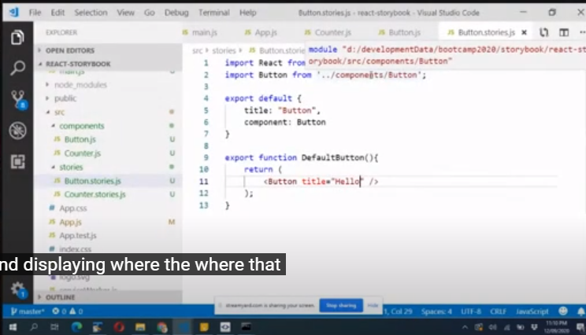

Now adding css, but in customizable way.

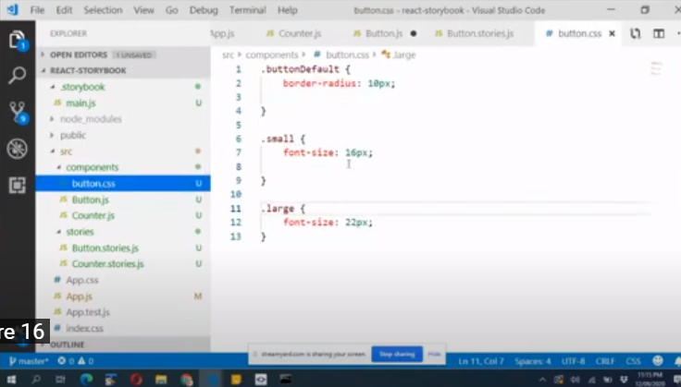

Using in button.js

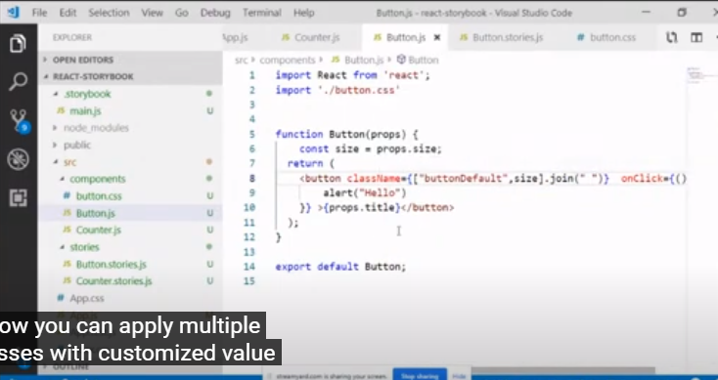

Now for customization, we can pass it different sizes(small and large) as per our need in button.stories.js

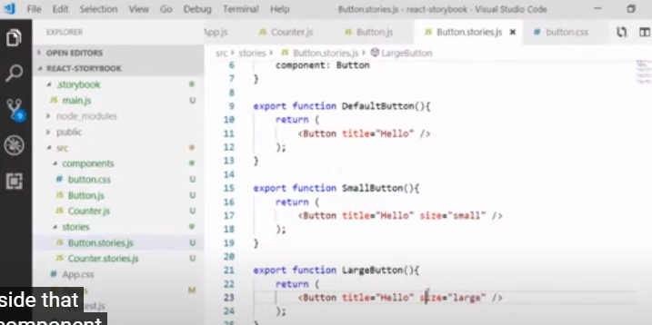

As when clicking on button run onclick, and so we also need to generalize onclick in button.js

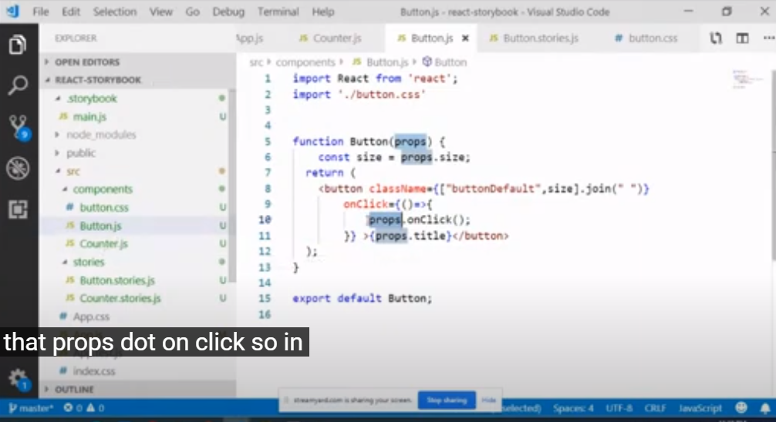

Now passing onClick button value in Counter.js

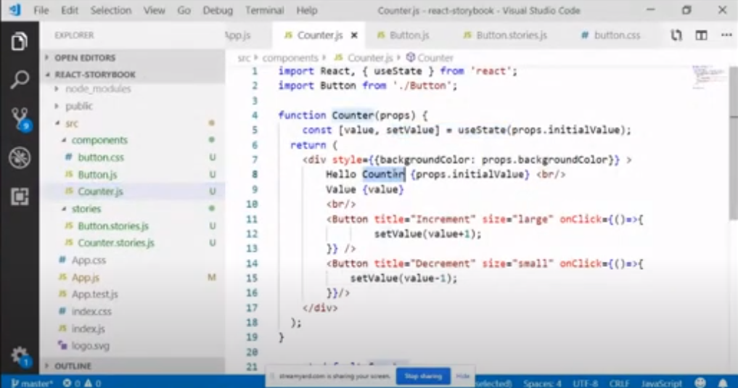

Now using this button component in stories to visualize the component separately

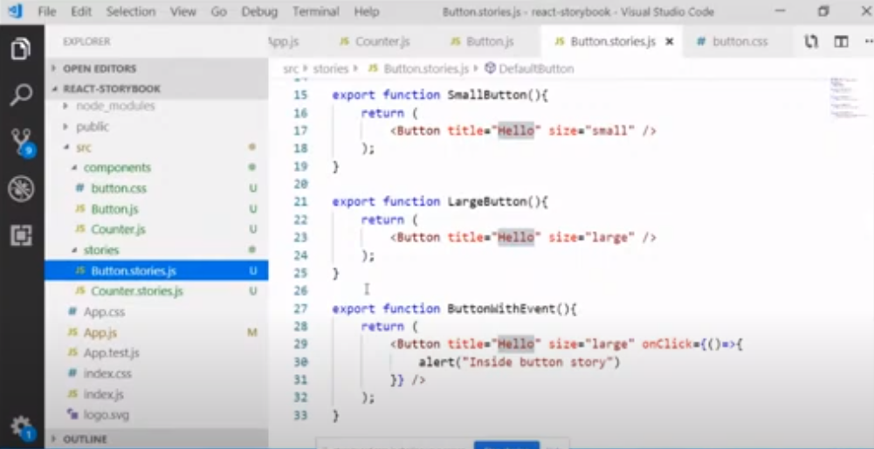

DECORATOR(ADDING KNOB):

It is like a wrapper that customize the value of same object within the stories. It is used in stories.

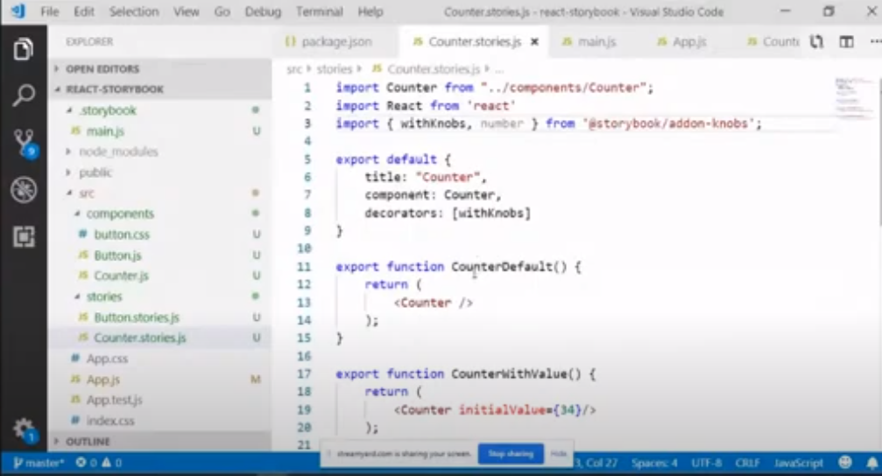

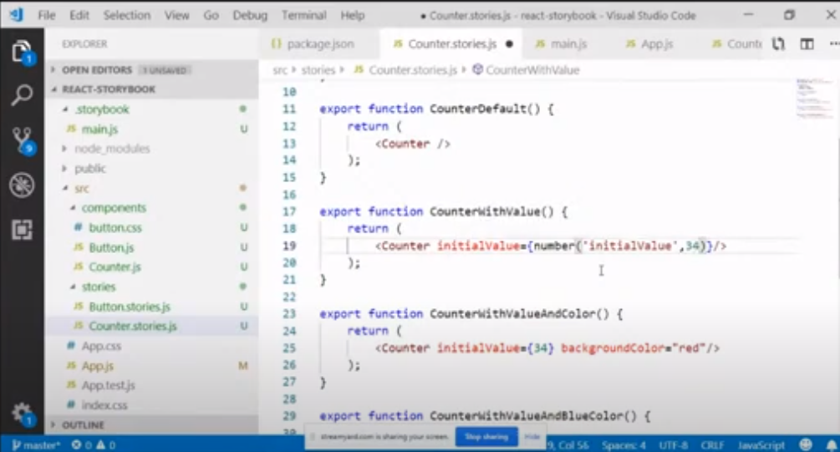

So by default it has value of 34, but it can be updated any time by providing some other value